DEPLOYEMENT DOCUMENT FOR WEB3
Step : 1
- URL have given from Sekar Sir.
Step : 2
- Then You have check Command prompt. You have get in which server bind in url.
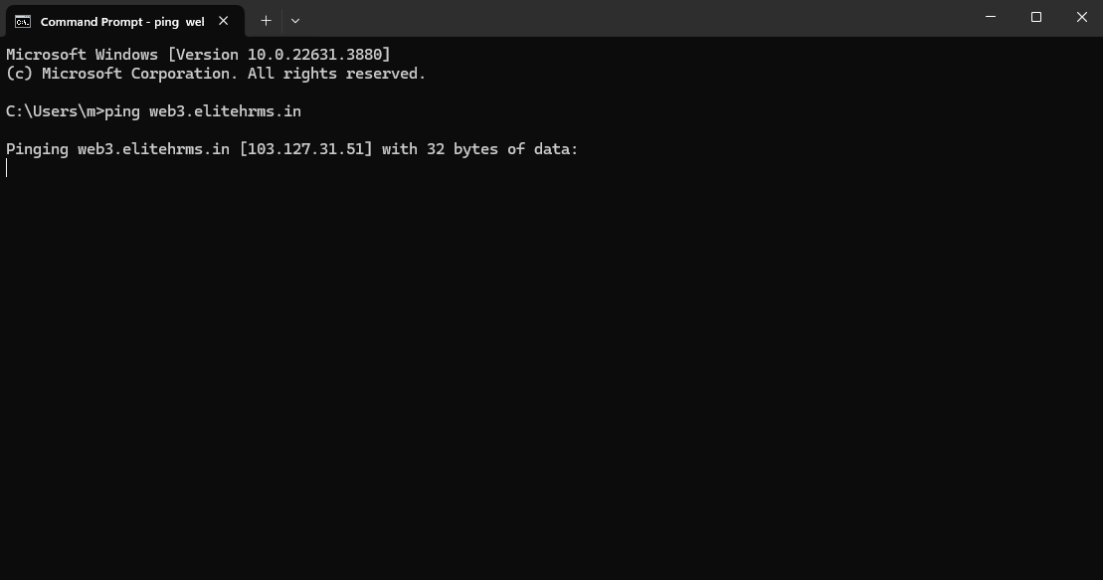
Step : 3
- Then open in particular server IIS Managaer
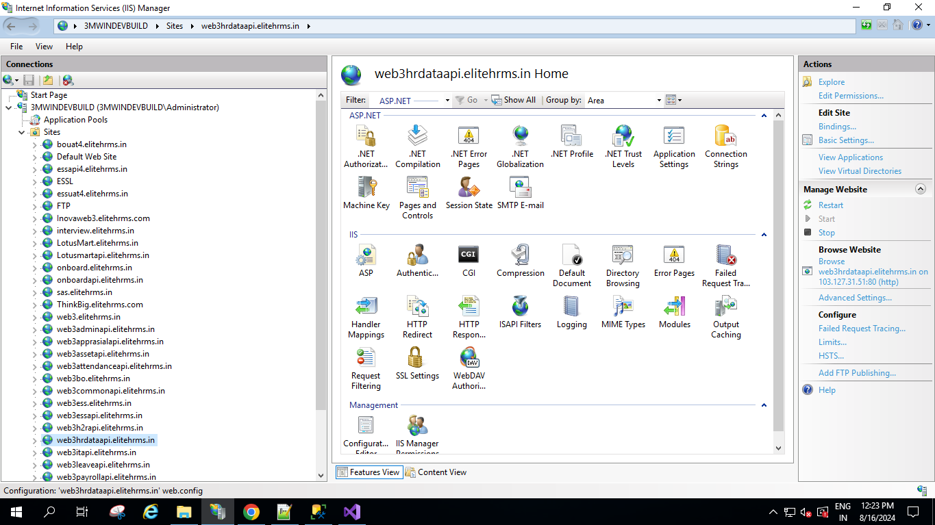

Step : 4
- Then Click Site and Click Right Click then Click Add Web Site
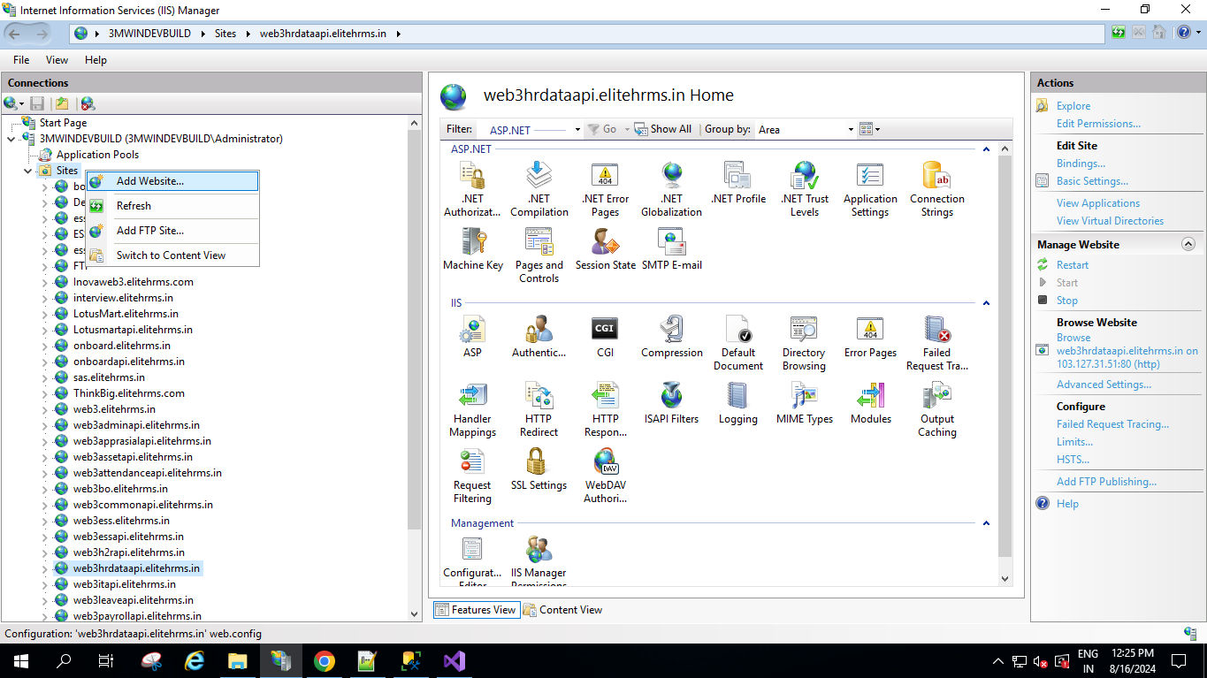
Step : 5
- Pop up have opened.
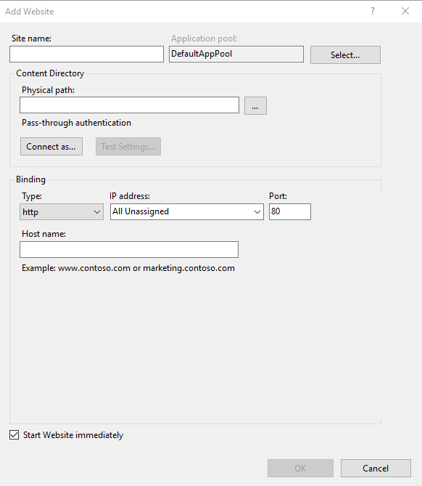
- Sit name, Physical path, binding Type, IP Address and Host name have enetered then click ok.

Step : 6
- Url have show in Site.
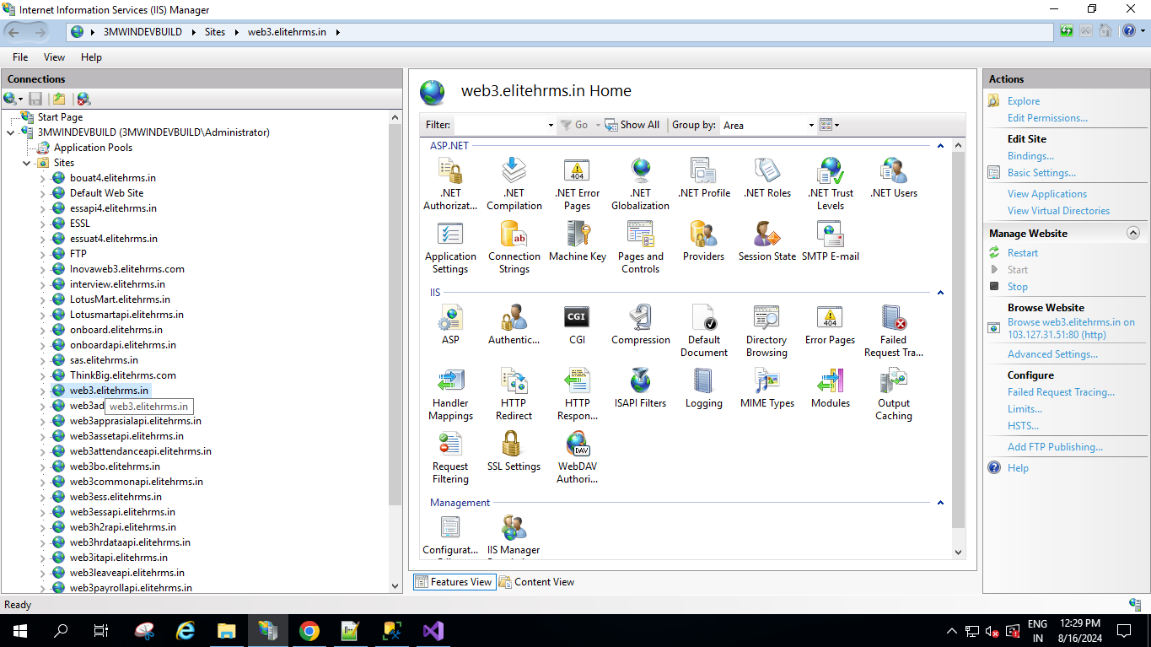
Step : 7
- Then Click URL in Right Click. Then Click Explore option to get the Physical path that path have give all Dll and Folder.
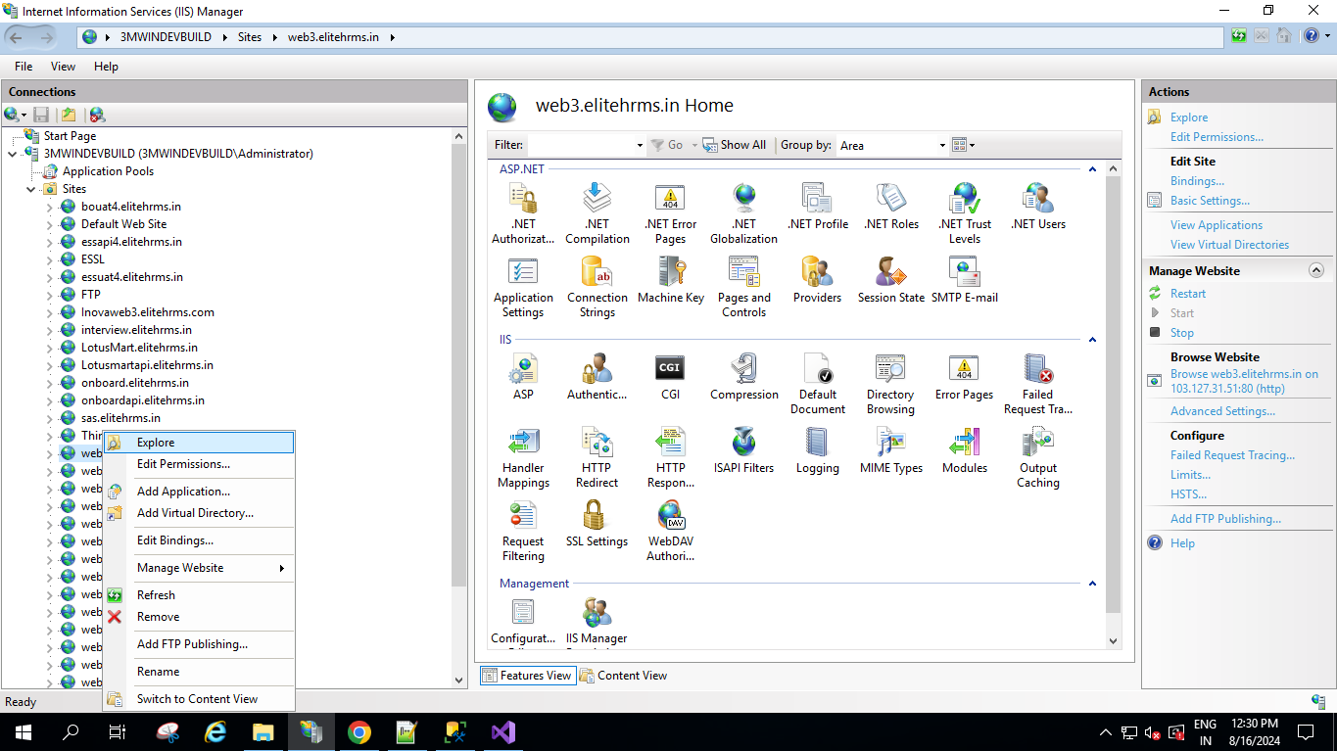
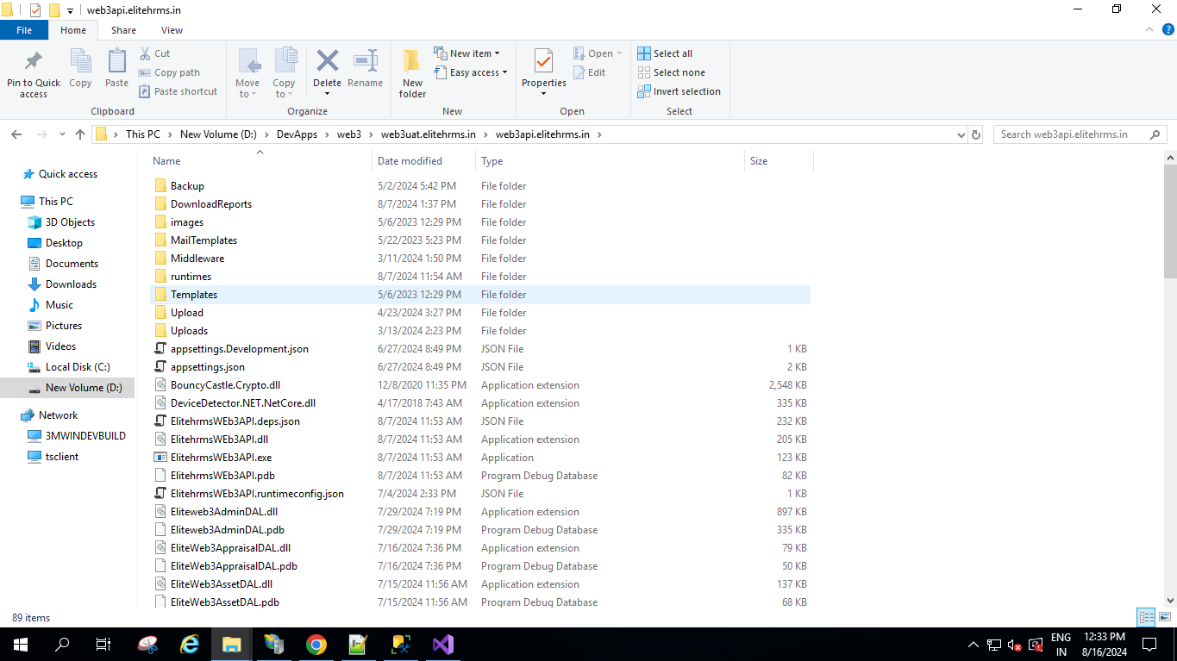
Step : 8 Sub Domain Creation
- Then Click Site url in Right click then click add application
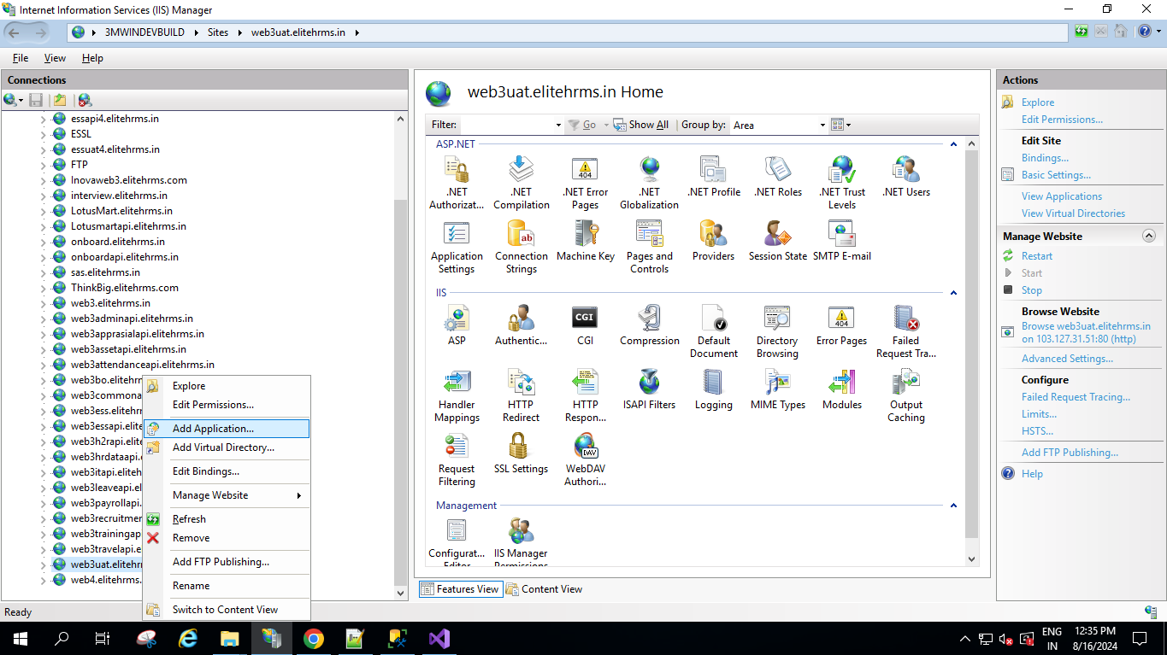
Step : 9
- Then pop have opened.
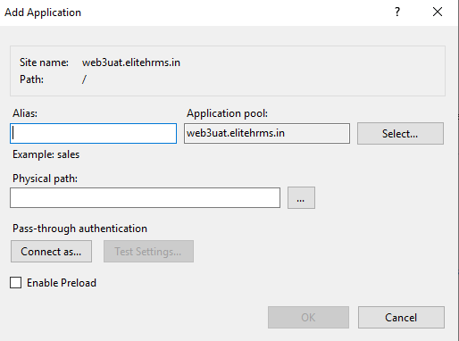
- Alais name, Physical path have give and click ok.

Step : 10
- Sub Domain have created.
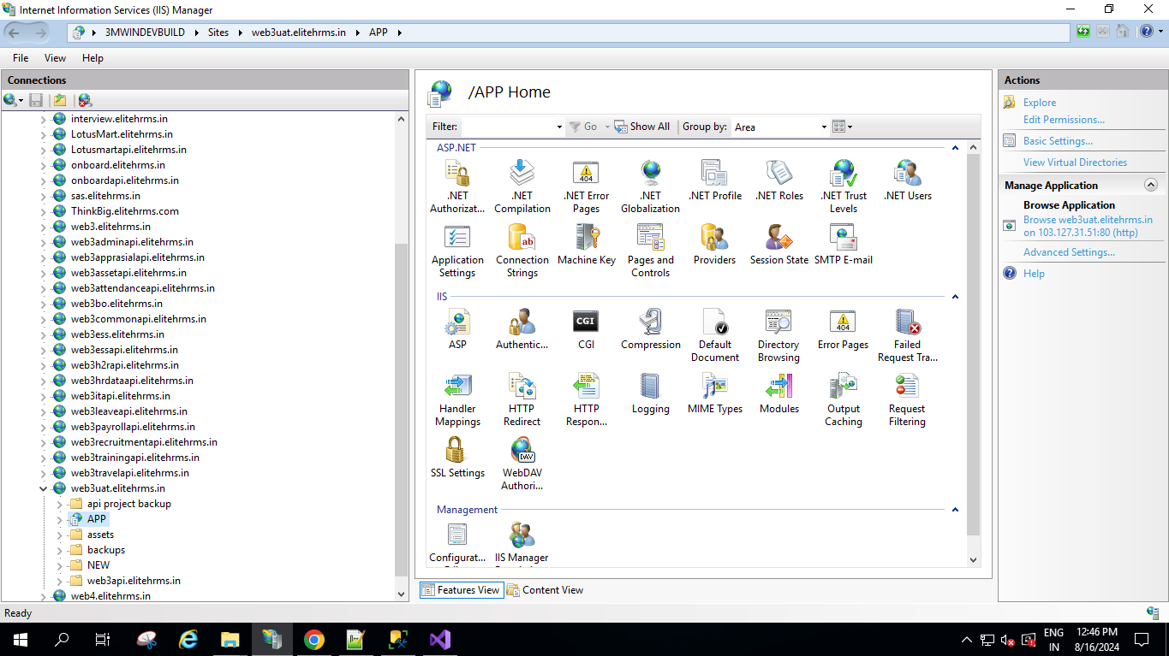
Step : 11
- Then Click Sub domain in Right click, then click Exploar.
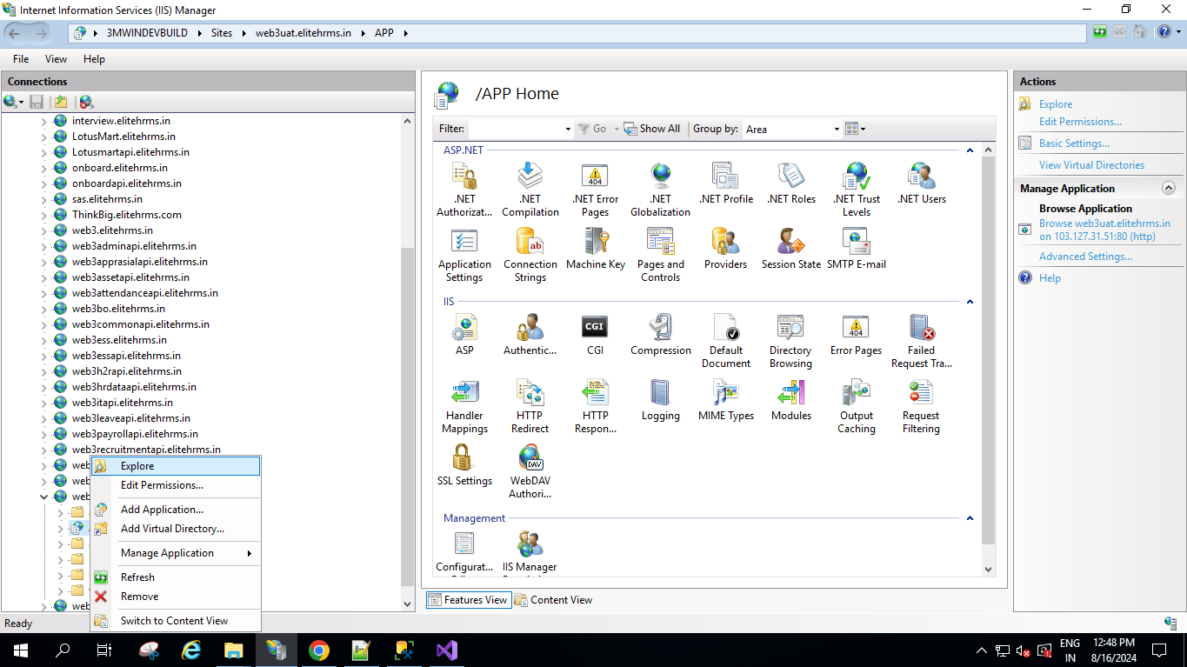
- Then Click Explore option to get the Physical path that path have give all Dll and Folder.

